Day -1 Task(Assignment)

21/03/2022

**Difference between HTTP1.1 vs HTTP2**

HTTP/2 improved on HTTP/1.1 in a number of ways that allowed for speedier content delivery and improved user experience, including:

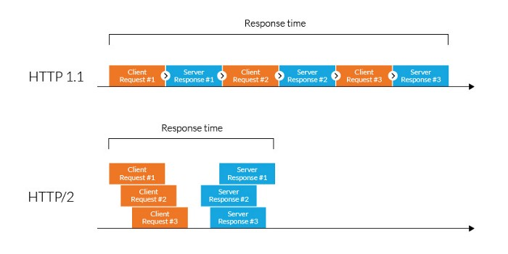

**Binary protocols :**

* Binary protocols consume less bandwidth, are more efficiently parsed and are less error-prone than the textual protocols used by HTTP/1.1. Additionally, they can better handle elements such as whitespace, capitalization and line endings

**Multiplexing :**

* HTTP/2 is multiplexed, i.e., it can initiate multiple requests in parallel over a single TCP connection. As a result, web pages containing several elements are delivered over one TCP connection. These capabilities solve the head-of-line blocking problem in HTTP/1.1, in which a packet at the front of the line blocks others from being transmitted.

**Header compression :**

* HTTP/2 uses header compression to reduce the overhead caused by TCP’s [s](https://en.wikipedia.org/wiki/TCP_congestion_control#Slow_start)low start mechanism.

**Server push :**

* HTTP/2 servers push likely-to-be-used resources into a browser’s cache, even before they’re requested. This allows browsers to display content without additional request cycles.

**Increased security :**

* Web browsers only support HTTP/2 via encrypted connections, increasing user and application security.

**Main goals of developing HTTP/2 was:**

* Protocol negotiation mechanism — protocol electing, eg. HTTP/1.1, HTTP/2 or other.
* High-level compatibility with HTTP/1.1 — methods, status codes, URIs and header fields.
* Page load speed improvements trough:
* Compression of request headers
* Binary protocol
* HTTP/2 Server Push
* Request multiplexing over a single TCP connection
* Request pipelining
* HOL blocking (Head-of-line) — Package blocking